Lab 11 – Data Structures with AI: Implementing Fundamental
Structures

Name: S.vamshi
Roll no: 2503A52416
Batch: 14

Task Description #1 – Stack Implementation
Task: Use AI to generate a Stack class with push, pop, peek, and is_empty
methods.

Input:
class Stack:
"""A simple Stack implementation using a list."""

def __init__(self):
"""Initialize an empty stack."""
self.items = []

def push(self, item):
"""Add an item to the top of the stack."""
self.items.append(item)

def pop(self):
"""Remove and return the top item from the stack."""
if self.is_empty():
return None
return self.items.pop()

def peek(self):
"""Return the top item without removing it."""
if self.is_empty():
return None
return self.items[-1]

def is_empty(self):
"""Return True if the stack is empty, otherwise False."""
return len(self.items) == 0

# Example usage
stack = Stack()

stack.push(10)
stack.push(20)
stack.push(30)

print("Top element:", stack.peek())
print("Popped element:", stack.pop())
print("Is stack empty?", stack.is_empty())

Explanation:
A Stack is a LIFO (Last In, First Out) data structure where the last inserted element is removed first.
push() adds an element, pop() removes the top element, and peek() returns the top element without removing it.
is_empty() checks whether the stack contains any elements.

Output:
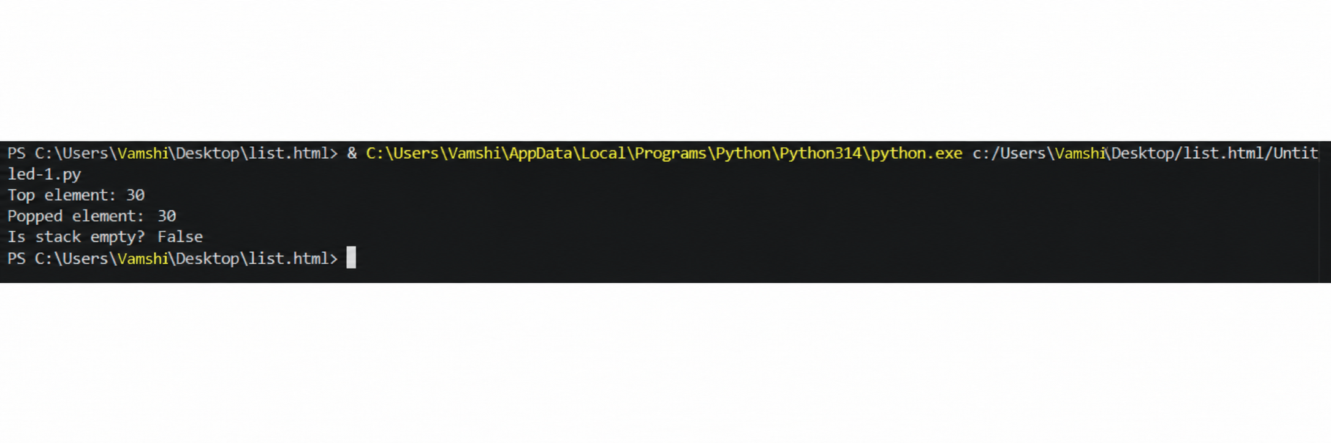

Task Description #2 – Queue Implementation
Task: Use AI to implement a Queue using Python lists.

Input:
class Queue:
"""A simple Queue implementation using a Python list."""

def __init__(self):
"""Initialize an empty queue."""
self.items = []

def enqueue(self, item):
"""Add an item to the rear of the queue."""
self.items.append(item)

def dequeue(self):
"""Remove and return the front item from the queue."""
if len(self.items) == 0:
return None
return self.items.pop(0)

def peek(self):
"""Return the front item without removing it."""
if len(self.items) == 0:
return None
return self.items[0]

def size(self):
"""Return the number of items in the queue."""
return len(self.items)

# Example usage
queue = Queue()

queue.enqueue(10)
queue.enqueue(20)
queue.enqueue(30)

print("Front element:", queue.peek())
print("Dequeued element:", queue.dequeue())
print("Queue size:", queue.size())

Explanation:
A Queue is a FIFO (First In, First Out) data structure, where the first inserted element is removed first.
enqueue() adds an element, dequeue() removes the front element, and peek() returns the front element without removing it.
size() returns the number of elements currently present in the queue.

Output:
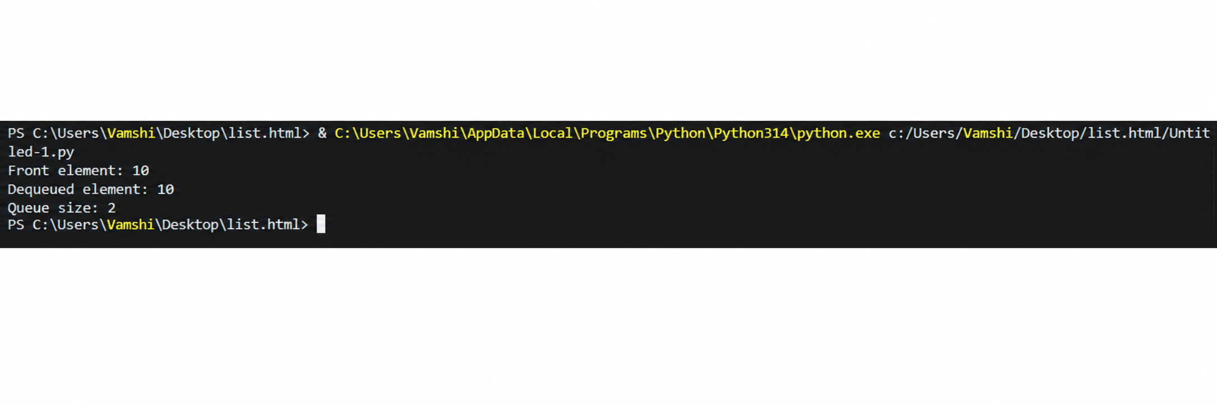

Task Description #3 – Linked List
Task: Use AI to generate a Singly Linked List with insert and display
methods.

Input:
class Node:
"""Represents a node in a singly linked list."""

def __init__(self, data):
"""Initialize a node with data and a next pointer."""
self.data = data
self.next = None

class LinkedList:
"""A simple singly linked list implementation."""

def __init__(self):
"""Initialize an empty linked list."""
self.head = None

def insert(self, data):
"""Insert a new node at the end of the linked list."""
new_node = Node(data)

if self.head is None:
self.head = new_node
return

current = self.head
while current.next is not None:
current = current.next

current.next = new_node

def display(self):
"""Display all elements of the linked list."""
current = self.head

while current is not None:
print(current.data, end=" -> ")
current = current.next

print("None")

# Example usage
linked_list = LinkedList()

linked_list.insert(10)
linked_list.insert(20)
linked_list.insert(30)
linked_list.insert(40)

print("Linked List:")
linked_list.display()

Explanation:
A Singly Linked List is a linear data structure made of nodes, where each node stores data and a link to the next node.
The insert() method adds a new node to the list, while the display() method prints all elements from the first node to the last.
Each node points only to the next node, and the last node points to None.

Output:
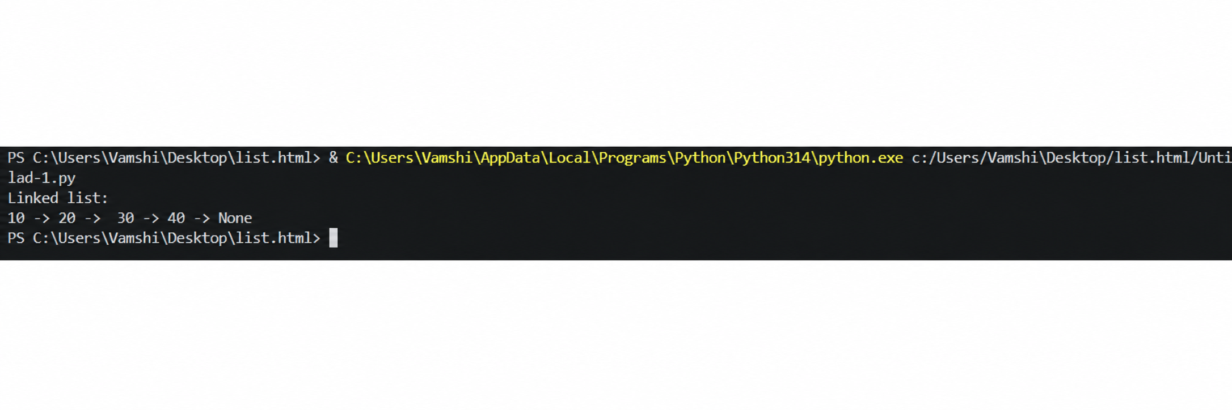

Task Description #4 – Binary Search Tree (BST)
Task: Use AI to create a BST with insert and in-order traversal methods.
Input:
class Node:
"""Represents a node in a Binary Search Tree."""

def __init__(self, data):
"""Initialize a node with data and two child pointers."""
self.data = data
self.left = None
self.right = None

class BST:
"""Binary Search Tree with recursive insertion and traversal."""

def __init__(self):
"""Initialize an empty Binary Search Tree."""
self.root = None

def insert(self, root, data):
"""Recursively insert a value into the BST."""
if root is None:
return Node(data)

if data < root.data:
root.left = self.insert(root.left, data)
elif data > root.data:
root.right = self.insert(root.right, data)

return root

def inorder(self, root):
"""Perform recursive in-order traversal of the BST."""
if root is not None:
self.inorder(root.left)
print(root.data, end=" ")
self.inorder(root.right)

# Example usage
bst = BST()

values = [50, 30, 70, 20, 40, 60, 80]

for value in values:
bst.root = bst.insert(bst.root, value)

print("In-order Traversal:")
bst.inorder(bst.root)
Explanation:
A Binary Search Tree (BST) is a tree where smaller values are stored on the left and larger values on the right.
The insert() method recursively places a new value in its correct position in the tree.
The inorder() traversal recursively visits left → root → right, producing values in sorted order.

Output:
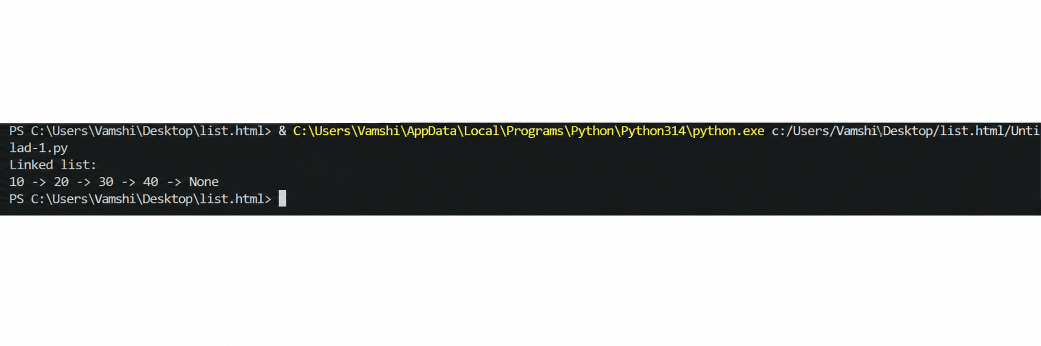

Task Description #5 – Priority Queue
Task: Use AI to implement a priority queue using Python’s heapq

Input:
import heapq

class PriorityQueue:
"""Priority Queue implementation using Python's heapq module."""

def __init__(self):
"""Initialize an empty priority queue."""
self.queue = []

def enqueue(self, priority, item):
"""Add an item with the given priority to the queue."""
heapq.heappush(self.queue, (priority, item))

def dequeue(self):
"""Remove and return the item with the highest priority."""
if not self.queue:
return None

priority, item = heapq.heappop(self.queue)
return item

def display(self):
"""Display all items in the priority queue."""
print("Priority Queue:")
for priority, item in sorted(self.queue):
print(f"Priority {priority}: {item}")

# Example usage
pq = PriorityQueue()

pq.enqueue(3, "Task C")
pq.enqueue(1, "Task A")
pq.enqueue(2, "Task B")

pq.display()

print("Dequeued:", pq.dequeue())
print("Dequeued:", pq.dequeue())

Explanation:
A Priority Queue is a data structure where each element is served according to its priority instead of insertion order.
Python’s heapq module implements a min-heap, so a smaller priority number represents a higher priority in this example.

Output:
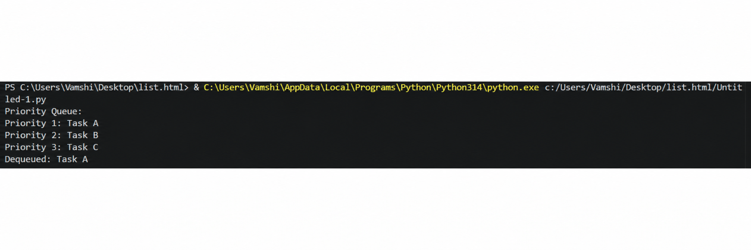
Task Description #6 – Deque
Task: Use AI to implement a double-ended queue using
collections.deque.
Input:
from collections import deque

class DequeDS:
"""A double-ended queue implementation using collections.deque."""

def __init__(self):
"""Initialize an empty deque."""
self.items = deque()

def insert_front(self, item):
"""Insert an item at the front of the deque."""
self.items.appendleft(item)

def insert_rear(self, item):
"""Insert an item at the rear of the deque."""
self.items.append(item)

def remove_front(self):
"""Remove and return the item from the front."""
if not self.items:
return None
return self.items.popleft()

def remove_rear(self):
"""Remove and return the item from the rear."""
if not self.items:
return None
return self.items.pop()

def display(self):
"""Display all elements in the deque."""
print("Deque:", list(self.items))

# Example usage
dq = DequeDS()

dq.insert_rear(10)
dq.insert_rear(20)
dq.insert_front(5)

dq.display()

print("Removed from front:", dq.remove_front())
print("Removed from rear:", dq.remove_rear())

dq.display()

Explanation:
A Deque (Double-Ended Queue) allows insertion and deletion of elements from both the front and rear ends.
Python’s collections.deque provides efficient methods such as append(), appendleft(), pop(), and popleft().

Output:
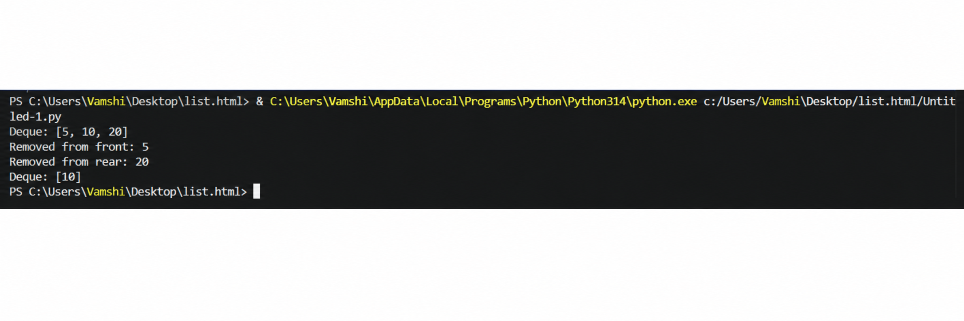
Task Description #7 Real-Time Application Challenge – Choose the
Right Data Structure
Scenario:
Your college wants to develop a Campus Resource Management System
that handles:
1. Student Attendance Tracking – Daily log of students
entering/exiting the campus.
2. Event Registration System – Manage participants in events with
quick search and removal.
3. Library Book Borrowing – Keep track of available books and their
due dates.

4. Bus Scheduling System – Maintain bus routes and stop
connections.
5. Cafeteria Order Queue – Serve students in the order they arrive.

Input:
from collections import deque

class CafeteriaQueue:
"""Manage cafeteria orders using a FIFO queue."""

def __init__(self):
"""Initialize an empty cafeteria order queue."""
self.orders = deque()

def add_order(self, student_name, order):
"""Add a student's order to the rear of the queue."""
self.orders.append((student_name, order))

def serve_order(self):
"""Remove and serve the order at the front of the queue."""
if not self.orders:
return None

return self.orders.popleft()

def display_orders(self):
"""Display all waiting cafeteria orders."""
if not self.orders:
print("No pending orders.")
return

print("Pending Orders:")
for student, order in self.orders:
print(f"{student} - {order}")

# Example usage
cafeteria = CafeteriaQueue()

# Students place their orders
cafeteria.add_order("Rahul", "Dosa")
cafeteria.add_order("Priya", "Burger")
cafeteria.add_order("Arjun", "Biryani")

# Display pending orders
cafeteria.display_orders()

# Serve orders in FIFO order
print("\nServing:", cafeteria.serve_order())
print("Serving:", cafeteria.serve_order())

# Display remaining orders
print("\nRemaining Orders:")
cafeteria.display_orders()

Explanation:
The Queue is appropriate for the cafeteria because it maintains the order in which students arrive. The implementation uses Python's deque to efficiently add orders at the rear and remove served orders from the front.

Output:
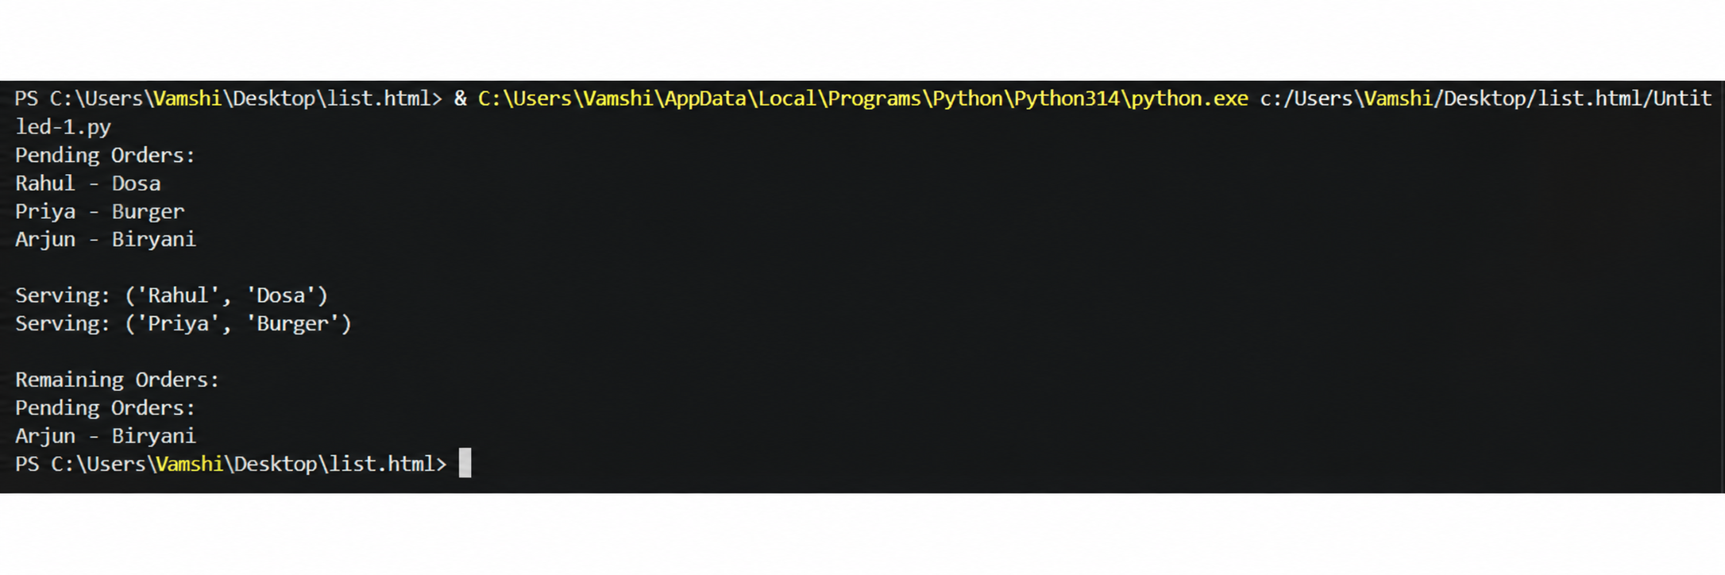

Task Description #8: Smart E-Commerce Platform – Data Structure
Challenge
An e-commerce company wants to build a Smart Online Shopping System
with:
1. Shopping Cart Management – Add and remove products
dynamically.
2. Order Processing System – Orders processed in the order they are
placed.
3. Top-Selling Products Tracker – Products ranked by sales count.

4. Product Search Engine – Fast lookup of products using product ID.
5. Delivery Route Planning – Connect warehouses and delivery
locations.

Input:
from collections import deque

class OrderQueue:
"""Manage e-commerce orders using a FIFO queue."""

def __init__(self):
"""Initialize an empty order queue."""
self.orders = deque()

def add_order(self, order_id, customer_name):
"""Add a new order to the rear of the queue."""
self.orders.append((order_id, customer_name))

def process_order(self):
"""Remove and process the oldest order."""
if not self.orders:
return None

return self.orders.popleft()

def display_orders(self):
"""Display all pending orders."""
if not self.orders:
print("No pending orders.")
return

print("Pending Orders:")
for order_id, customer in self.orders:
print(f"Order ID: {order_id}, Customer: {customer}")

# Example usage
order_queue = OrderQueue()

# Add orders
order_queue.add_order(101, "Rahul")
order_queue.add_order(102, "Priya")
order_queue.add_order(103, "Arjun")

# Display pending orders
order_queue.display_orders()

# Process orders
print("\nProcessing:", order_queue.process_order())
print("Processing:", order_queue.process_order())

# Display remaining orders
print("\nRemaining Orders:")
order_queue.display_orders()

Explanation:
The Queue is suitable for order processing because it maintains the order in which customers place their orders. The add_order() method adds new orders, while process_order() removes the oldest order first.

Output:
